# File permissions in Linux

## Project description

Using Linux commands, we are examining and modifying user, group and others’ read, write and execute permissions on the file system. If a permission does not match the authorization it was given, then it will be modified.

## Check file and directory details

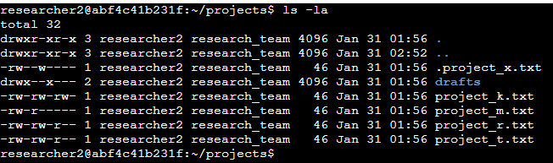

Using the command *ls -la* lists all files and directories and their permissions. The 10 character string at the beginning of the list shows this.

## Describe the permissions string

For example, the project_t.txt file has the permissions *-rw-rw-r--­*. The first character differentiates between files (‘-‘) and directories (‘d’). The next 9 characters are split into groups of 3. The first 3 characters belong to the user that owns the file, the next 3 are the group that owns the file and finally the last 3 belong to everyone else (other). The 3 characters list permissions for reading (r), writing (w), and executing (x). The project_t.txt file has permissions for the user to read and write, the group to read and write and for other to only read.

## Change file permissions

This organization does not allow other to have write permissions. Note the project_k.txt file has write permissions set to other. Using the chmod command, we are able to change the permissions of other to remove the write command. [chmod o-w project_t.txt]. The o represents the ‘other’ permissions, the operator ‘-‘ says to remove permissions and the w specifies write permissions.

## Change file permissions on a hidden file

The hidden file project_x.txt has been archived and must not be written to by anyone, but can be read by the user and the group. This file has write permissions for the user and the group and no read permissions for the group. In order to change this, we can specify multiple arguments to the chmod command separated by commas. [chmod u-w,g-w,g+r project_x.txt].

## Change directory permissions

Finally, only the researcher2 user should be able to access the drafts directory and its contents. In order to do this, we must remove the execute permissions from group, which is misconfigured. [chmod g-x drafts/]

## Summary

We have successfully modified the user permissions for the files and directories of this file system. We removed write permissions from other, protected archived data, and correctly configured the permissions for a directory.